DS Lab Mini Project

**Pac-man**

Done by:

Guru Pranav Shanubhog 01FB14ECS076

Desai Vishrudh Reddy 01FB14ECS065

Chintan Saxena 01FB14ECS062

Description:

The player controls Pac-Man through a maze, eating pac-dots . When all pac-dots are eaten, Pac-Man is taken to the next stage. Between some stages one of three intermission animations plays. Two enemies (inky, and Clyde) roam the maze, trying to catch Pac-Man. If an enemy touches Pac-Man,Pac-Man himself withers and dies. Whenever Pac-Man occupies the same tile as an enemy, he is considered to have collided with that ghost and a life is lost.

Data Structures Used:

LINKED LIST

**linked list has been used to control the movement and ghosts.**

**Every point of the maze is linked to all 4 adjacent points with linked list.We have also used linked list for the movement of pacman in different axes say,top ,left ,right,bottom.**

**Morover also the movement of the pacman should be restricted in the areas of walls.**

Algorithm:

Whenever the pacman is towards the left of the ghost, the ghost is made to move left,similarly the ghost is made to move right if the pacman is in the right position.

If pacman and ghost are in the same column the ghost is made to move towards the pacman.

Game Moves:

Basically in this game the movement of the pacman matters a lot. If we press any of the key say up,down,left,right it signifies the prescribed number that we had provided earlier,based on which the pacman moves.Once the pacman encounters with the ghosts the game is over ,or you win if pacman does not encounter with the ghost.

Tools Used:

Javascript:

**JavaScript**  is a high-level, dynamic, untyped, and interpreted programming language. It has been standardized in the ECMA Script language specification. Alongside HTML and CSS, it is one of the three essential technologies of World Wide Web content production; the majority of websites employ it and it is supported by all modern web browsers without plug-ins. JavaScript is prototype-based with first-class functions, making it a multi-paradigm language, supporting object-oriented, imperative, and functional programming styles. It has an API for working with text, arrays, dates and regular expressions, but does not include any I/O, such as networking, storage or graphics facilities, relying for these upon the host environment in which it is embedded.

Despite some naming, syntactic, and standard library similarities, JavaScript and Java are otherwise unrelated and have very different semantics. The syntax of JavaScript is actually derived from C, while the semantics and design are influenced by the Self  Scheme programming languages.

JavaScript is also used in environments that are not web-based, such as PDF documents,  site specific browser, and desktop widgets. Newer and faster JavaScript virtual machines (VMs) and platforms built upon them have also increased the popularity of JavaScript for server-side web applications. On the client side, JavaScript has been traditionally implemented as an interpreted language, but more recent browsers perform just-in-time compilation. It is also used in game development, the creation of desktop and mobile applications, and server-side network programming with runtime environments such as Node.js

Figure out the key presses

Is it a valid move?

T F

Stay in the same position

Move to the specified key direction

Caught by a Ghost?

T F

Game Continues

Game Over!.

F

Reached 275 Points!

T

Screenshots:

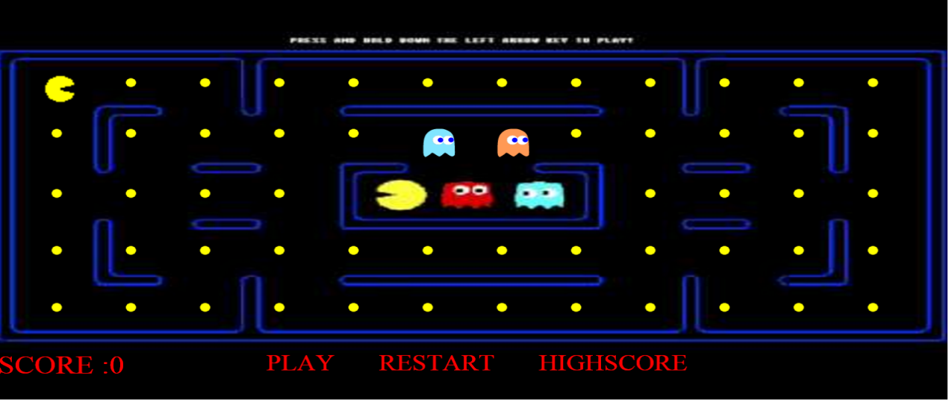

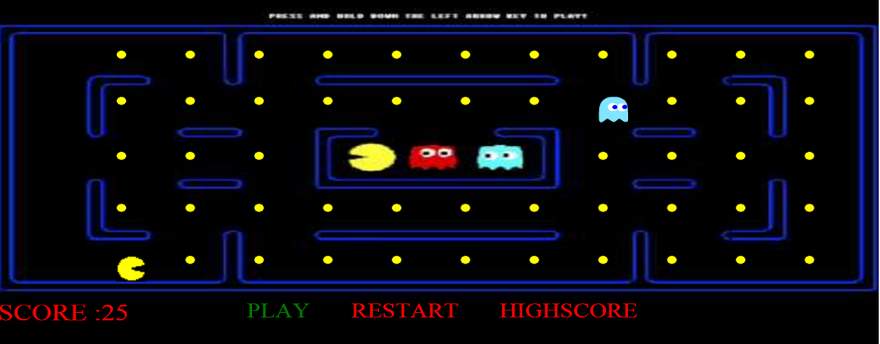

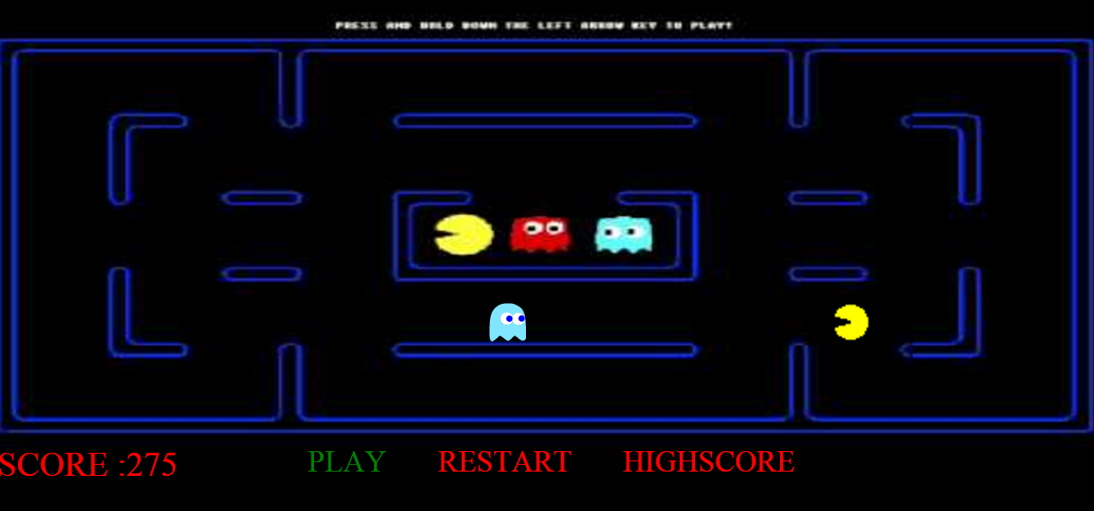

Conclusion:

We understood how Linked lists are implemented in applications

We understood how to use Javascript and learn its Graphics.

Limitations:

No further levels are provided

No animations during movement

High Score can’t be stored for every player

Number of steps will be increasing in case we try to move through walls

FUTURE ENHANCEMENT:

Animations during movement

Better User Interface

More enemies